Chapter 19, Solution 51.

To get and , consider the circuit in Fig. (a).
j 
-j3 
1 
+
−
(a)

I₂
+
V₁
−
V₂
I₁ = 0
j 
j2 
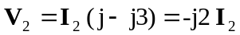

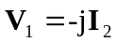

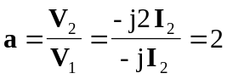

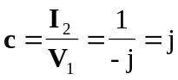

To get and , consider the circuit in Fig. (b).
j 
-j3 
1 
+
−
(b)

I₂
V₂
j 
j2 
I₁
+
V₁ = 0
−

For mesh 1,
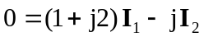
or 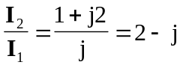

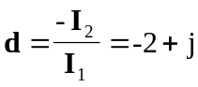

For mesh 2,
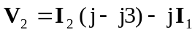

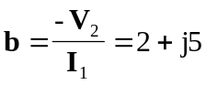

Thus,
